**PROJECT3 資訊108賴睿珣 f74041153**

**Screen shot**

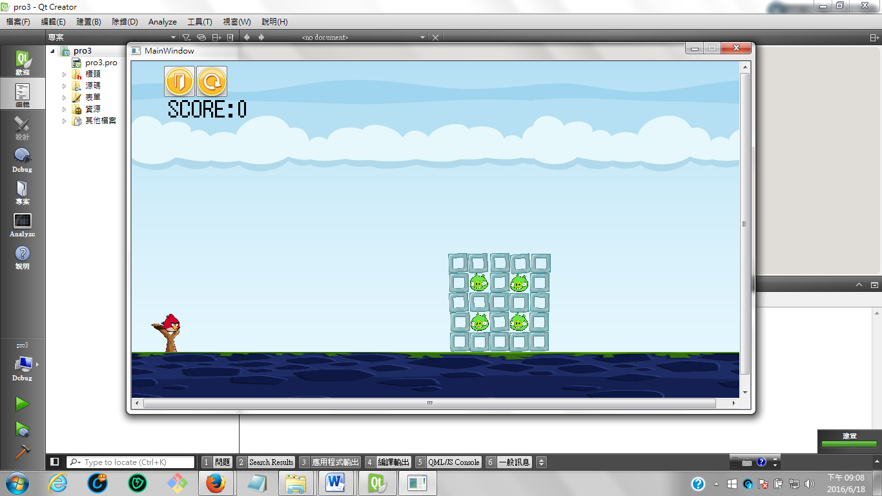

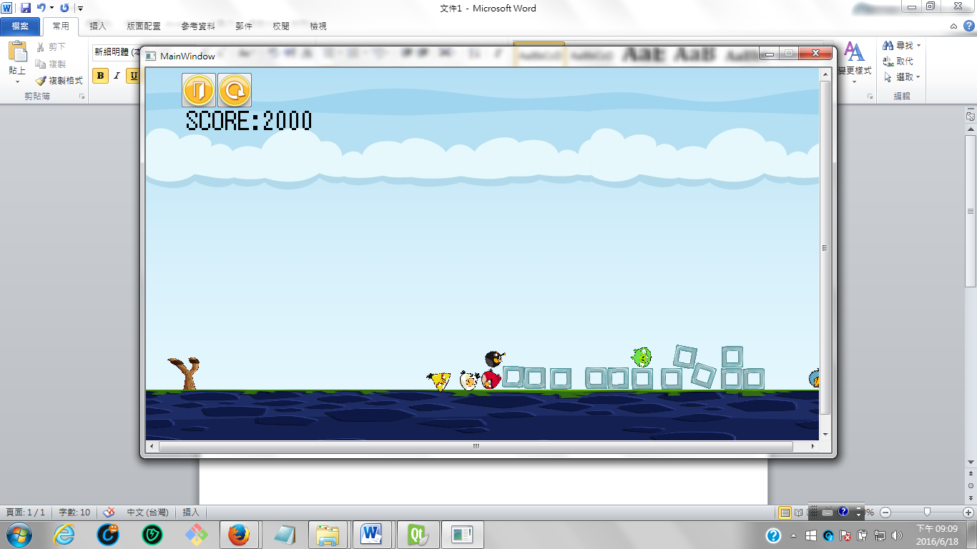

**How to play**

1. 點擊滑鼠左鍵
2. 按定後向左下方拉
3. 放開滑鼠左鍵
4. 鳥飛出
5. 撞擊方塊的力道達到一定程度得分(一定力量豬才會消失)

**Program architecture**

**UML**

|  |
| --- |
| mainwindow |
| <<constructor>>+MainWindow(parent = 0: QWidget *);  <<destructor>>+~MainWindow();  - ui: Ui::MainWindow *  - scene :QGraphicsScene *  - world b2World *  - itemList: QList<GameItem *>  - timer: QTimer  - start_point: b2Vec2  - bird[5]: Bird *  - birdie: Bird*  - land: Land*  - rope: Dangon *  - enemy[4] :Enemy *  - joint: b2MouseJoint*  -brick[5][5] :Block *  - count: Integer  - k_count: Integer  - j_count: Integer  - space_count: Integer  - L_count: Integer  -score:Score*;  - button1: QPushButton*  - button2: QPushButton* |
| +eventFilter(QObject *, event: QEvent *): bool  + closeEvent(QCloseEvent *):  +build_a_castle();  + quitGame();  -tick();  -QUITSLOT()  - create_bird()  -renew_mainwindow()  -keyPressEvent(event QKeyEvent*)  -restart()  -clock() |

|  |
| --- |
| Score |
| <<constructor>>+Score(parent=0: QGraphicsItem*)  - s:Integer |
| +increase()  +getscore():Interger |

|  |
| --- |
| Gameitem |
| <<constructor>>GameItem(world: b2World *)  <<destructor>> virtual ~GameItem()  + g_body: b2Body *  + g_pixmap: QGraphicsPixmapItem  # g_size: QSizeF  # static g_worldsize: QSizeF  # static g_windowsize: QSizeF  # g_world: b2World * |
| +static setGlobalSize(worldsize: QSizeF, windowsize:QSizeF)p  + paint() |

|  |
| --- |
| land |
| <<constuctor>>+Land(x: float, y: float, w: float, h: float, pixmap: QPixmap, world: b2World *, scene: QGraphicsScene *) |

|  |
| --- |
| Dangon |
| <<constuctor>>+Dangon(x: float, y: float, w: float, h: float, pixmap: QPixmap, world: b2World *, scene: QGraphicsScene *) |

|  |
| --- |
| Block |
| <<constuctor>>+Block(x: float, y: float, w: float, h: float, pixmap: QPixmap, world: b2World *, scene: QGraphicsScene *)  +Collide() |

|  |
| --- |
| enemy |
| <<constructor>>+ Enemy (x: float, y: float, w: float, h: float, pixmap: QPixmap, world: b2World *, scene: QGraphicsScene *) |
| + temp:Integer  + collide()  +remove() |

|  |
| --- |
| Bird |
| +<<constructor>Bird(world:b2World *)  +virtual~Bird(){}  + virtual key(){} |

|  |
| --- |
| Bird_one |
| <<constructor>>+Bird_one(x: float, y: float, w: float, h: float, pixmap: QPixmap, world: b2World *, scene: QGraphicsScene *);  <<destructor>>+ ~Bird_one(){};  + key() |

|  |
| --- |
| Bird_two |
| <<constructor>>+Bird_two(x: float, y: float, w: float, h: float, pixmap: QPixmap, world: b2World *, scene: QGraphicsScene *);  <<destructor>>+ ~Bird_two(){};  + key() |

|  |
| --- |
| Bird_three |
| <<constructor>>+Bird_three(x: float, y: float, w: float, h: float, pixmap: QPixmap, world: b2World *, scene: QGraphicsScene *);  <<destructor>>+ ~Bird_three(){};  + key() |

|  |
| --- |
| Bird_four |
| <<constructor>>+Bird_four(x: float, y: float, w: float, h: float, pixmap: QPixmap, world: b2World *, scene: QGraphicsScene *);  <<destructor>>+ ~Bird_four(){};  + key() |